


OpenLCB / NMRAnet
Developer and Early Adopter Kit

Tips

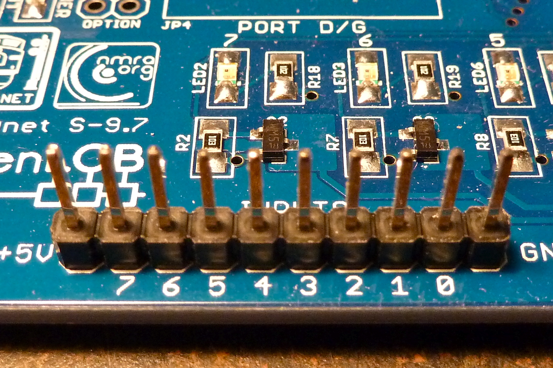
Use of Connectors

The Input and Output 1x10 positions can be filled with male or female 1x10 terminal strips, connections can then be by way of individual wires with female or male ends, or a cable with a 1x10 female or male header, respectively.
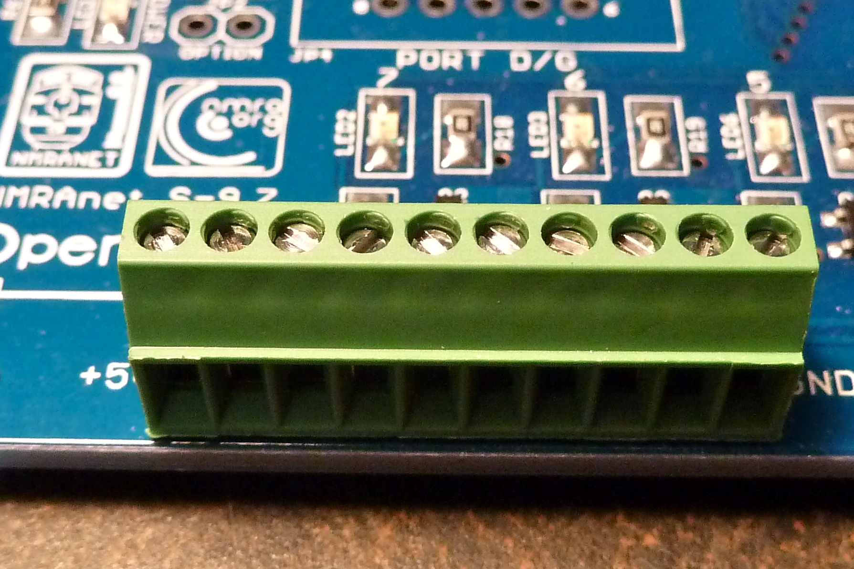
A more expensive, but possibly more user-friendly solution is to use a 10-position screw-terminal, as shown to the right. One screw-terminal is included in the kit.

The Additional 2x5 Connectors

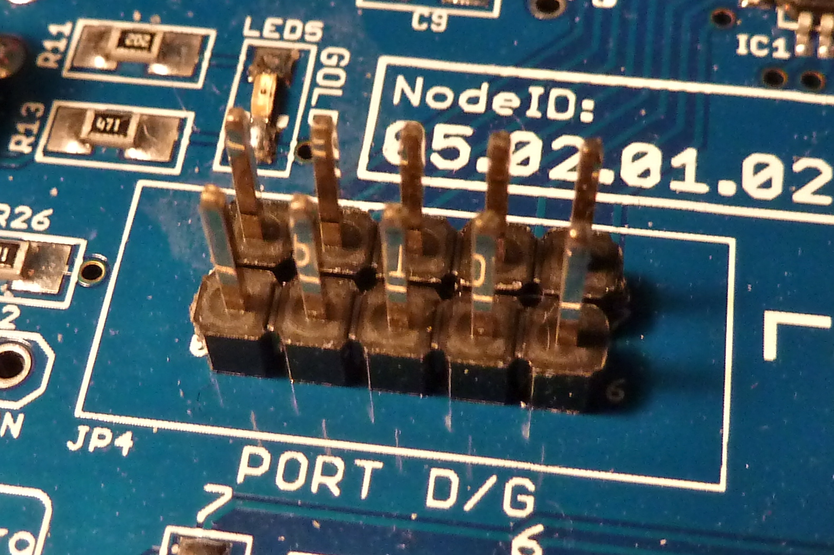
These auxiliary connectors can be populated in a variety of ways. These should be populated only if you are going to use them for a specific task. Some of the demonstration code may use these connectors, and these would require installation of connectors.
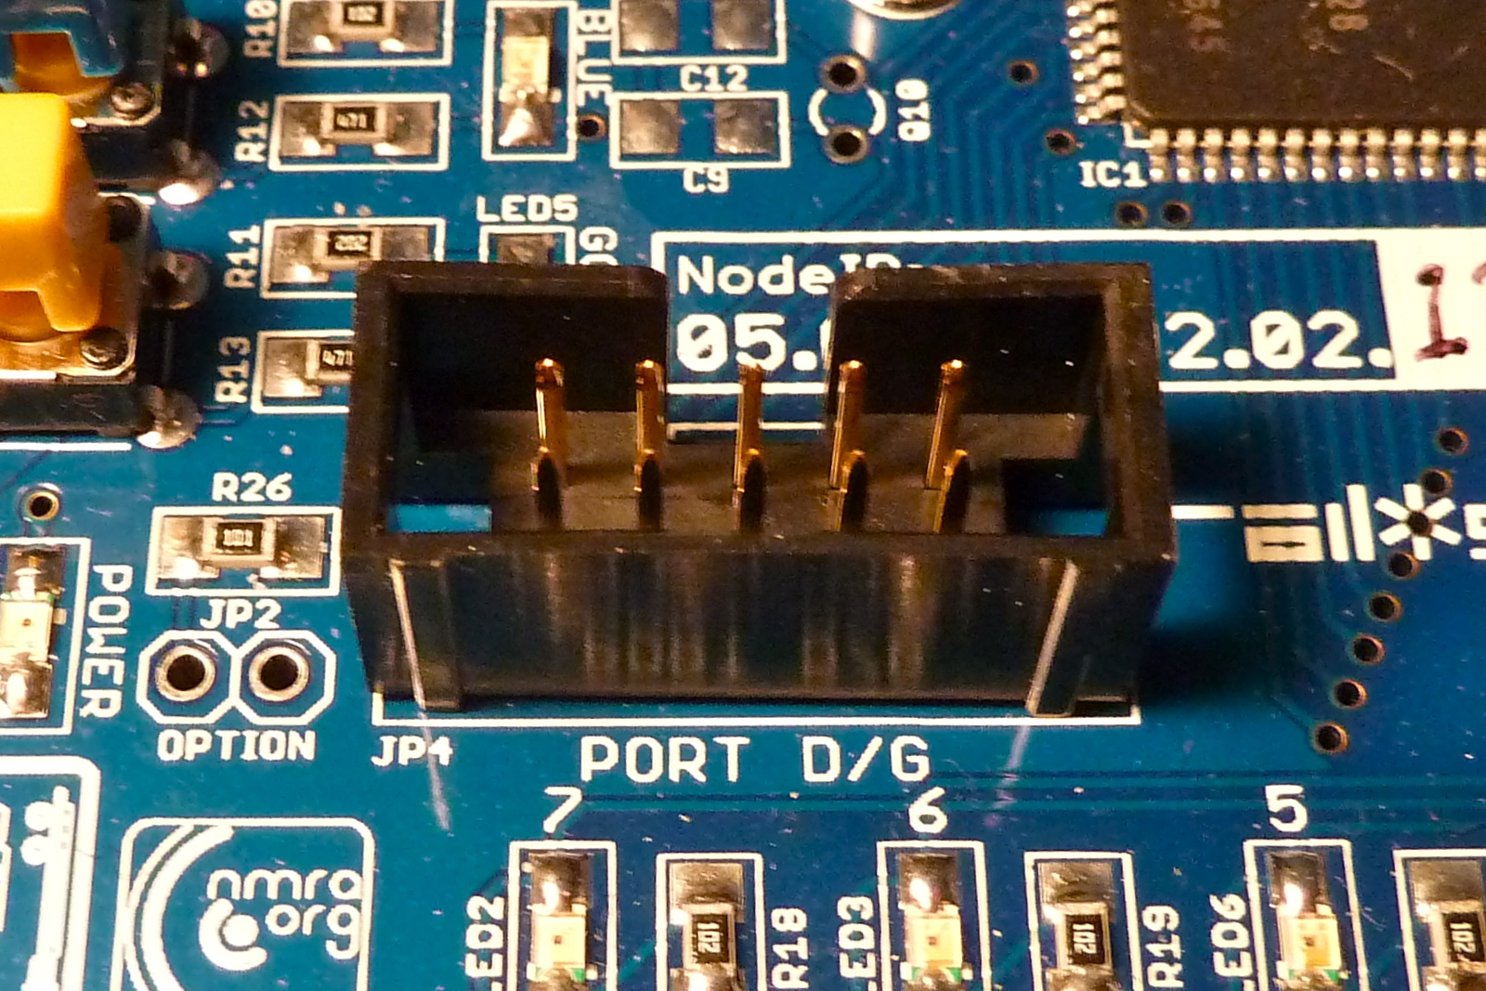
The cheapest method is to install two 1x5 male pin headers, as shown to the top-right. A more expensive method is to use a hooded 2x5 connector. These come with keying, so that the can prevent you from inserting the ribbon cables the wrong way around

The ButtonLED8 boards are designed to be easy to use with the additional connectors. The pictures below shows how these boards connect to the Io.

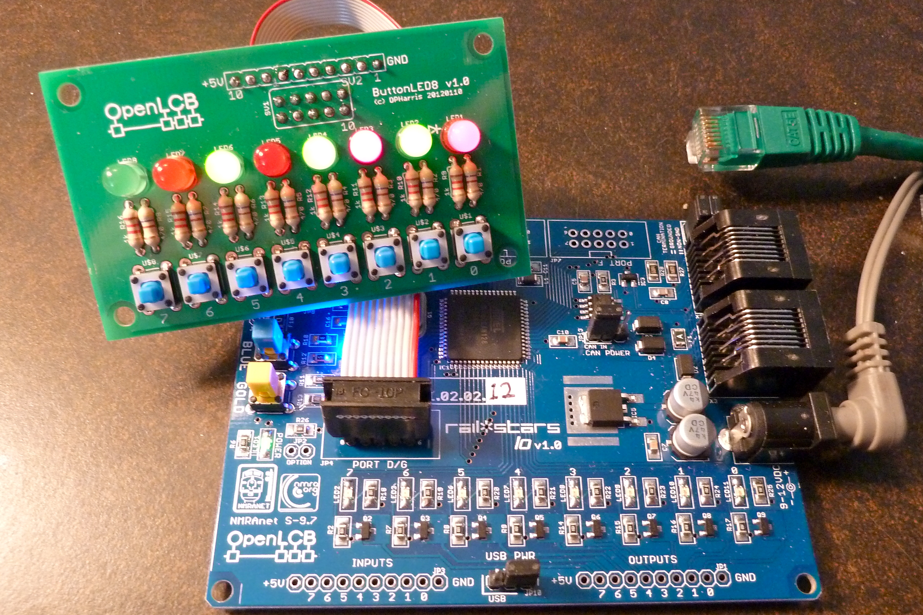
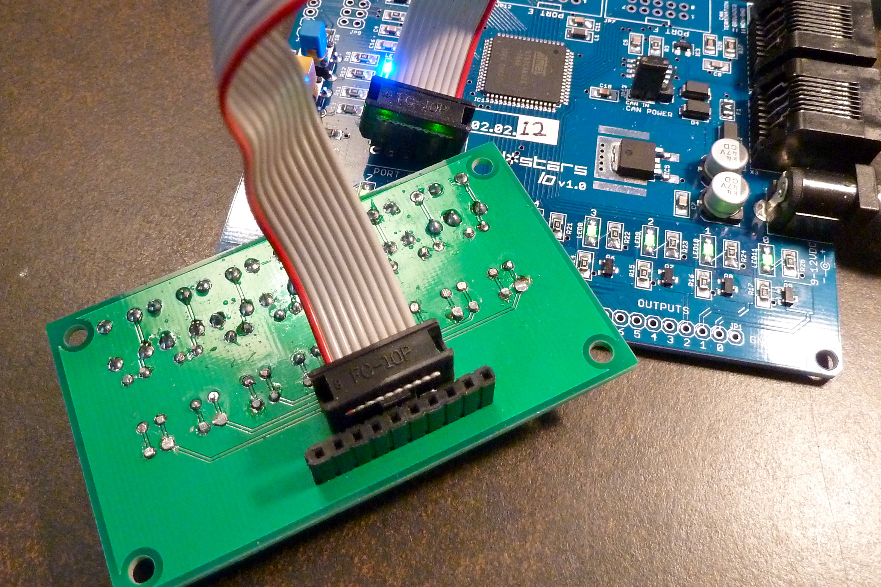
Programming an Io

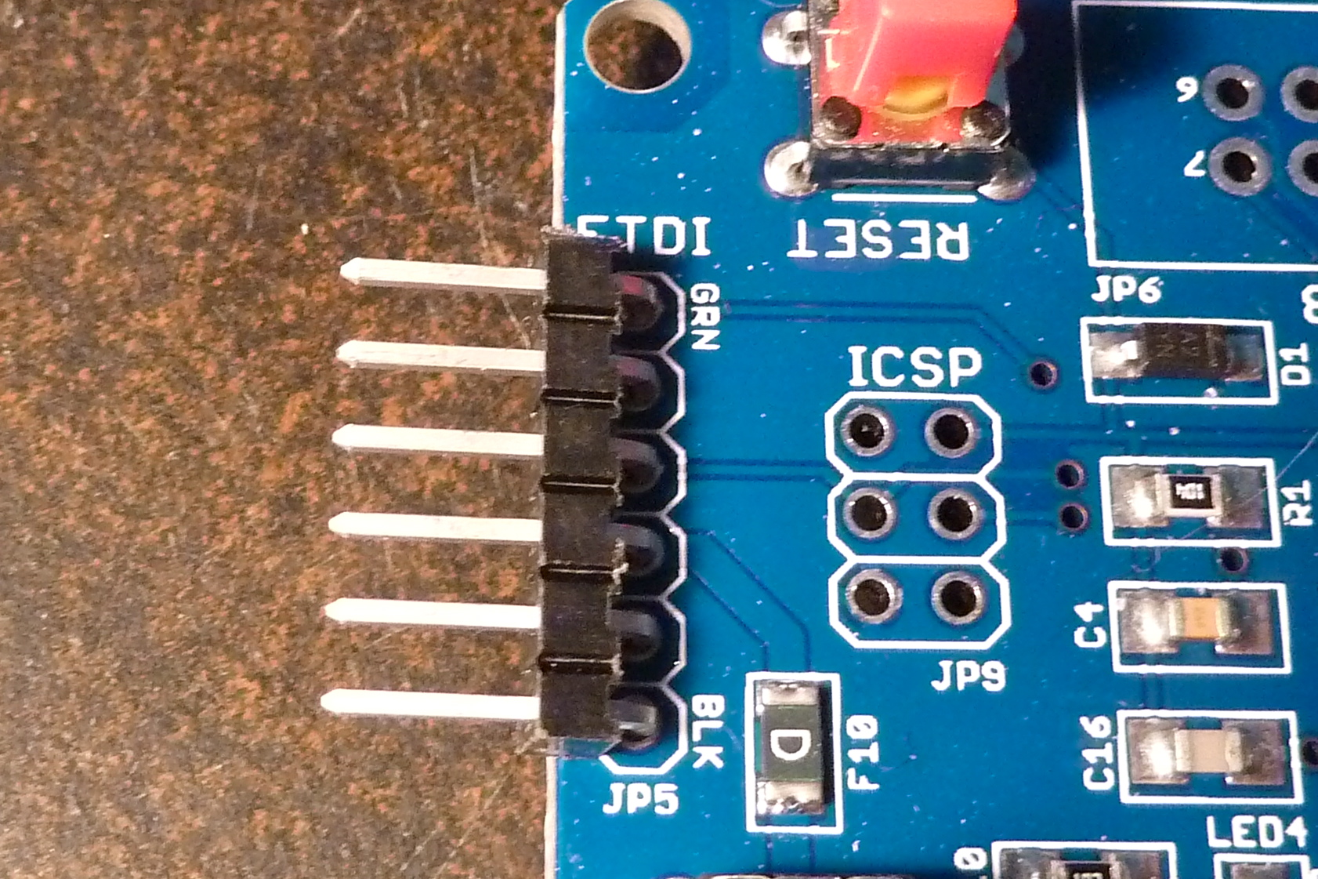
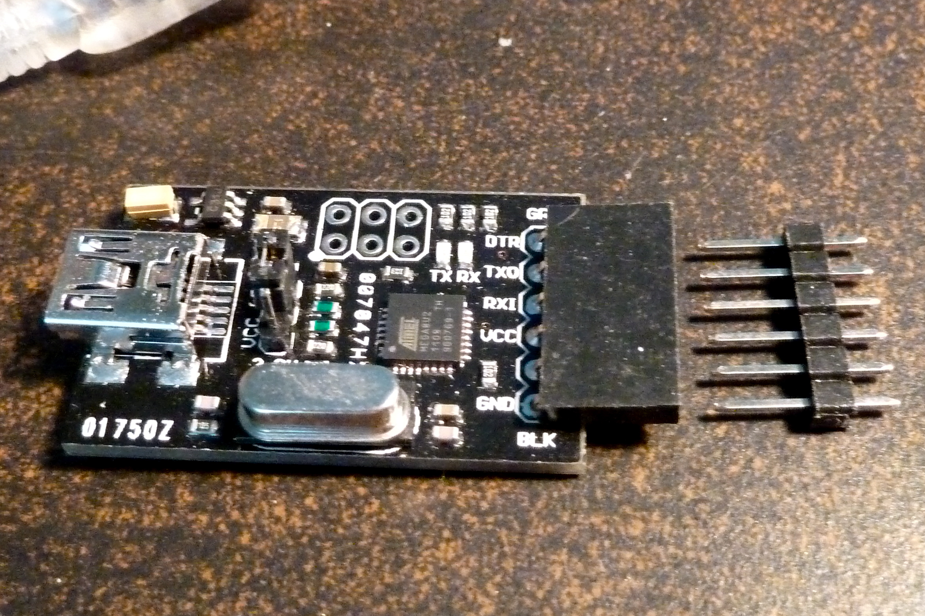
An Io can be re-programmed by using its bootloader and the USBSerial board. To make this easier, if you think you might want to do this often, you can install 1x6 male connector strip, either a right-angle, as show to the right, or a straight-up connector. The right-angle connector has the advantage that it lets the USBSerial lie flat, but the disadvantage is that the pins extend past the board edge.

Using USBSerial without a connector:

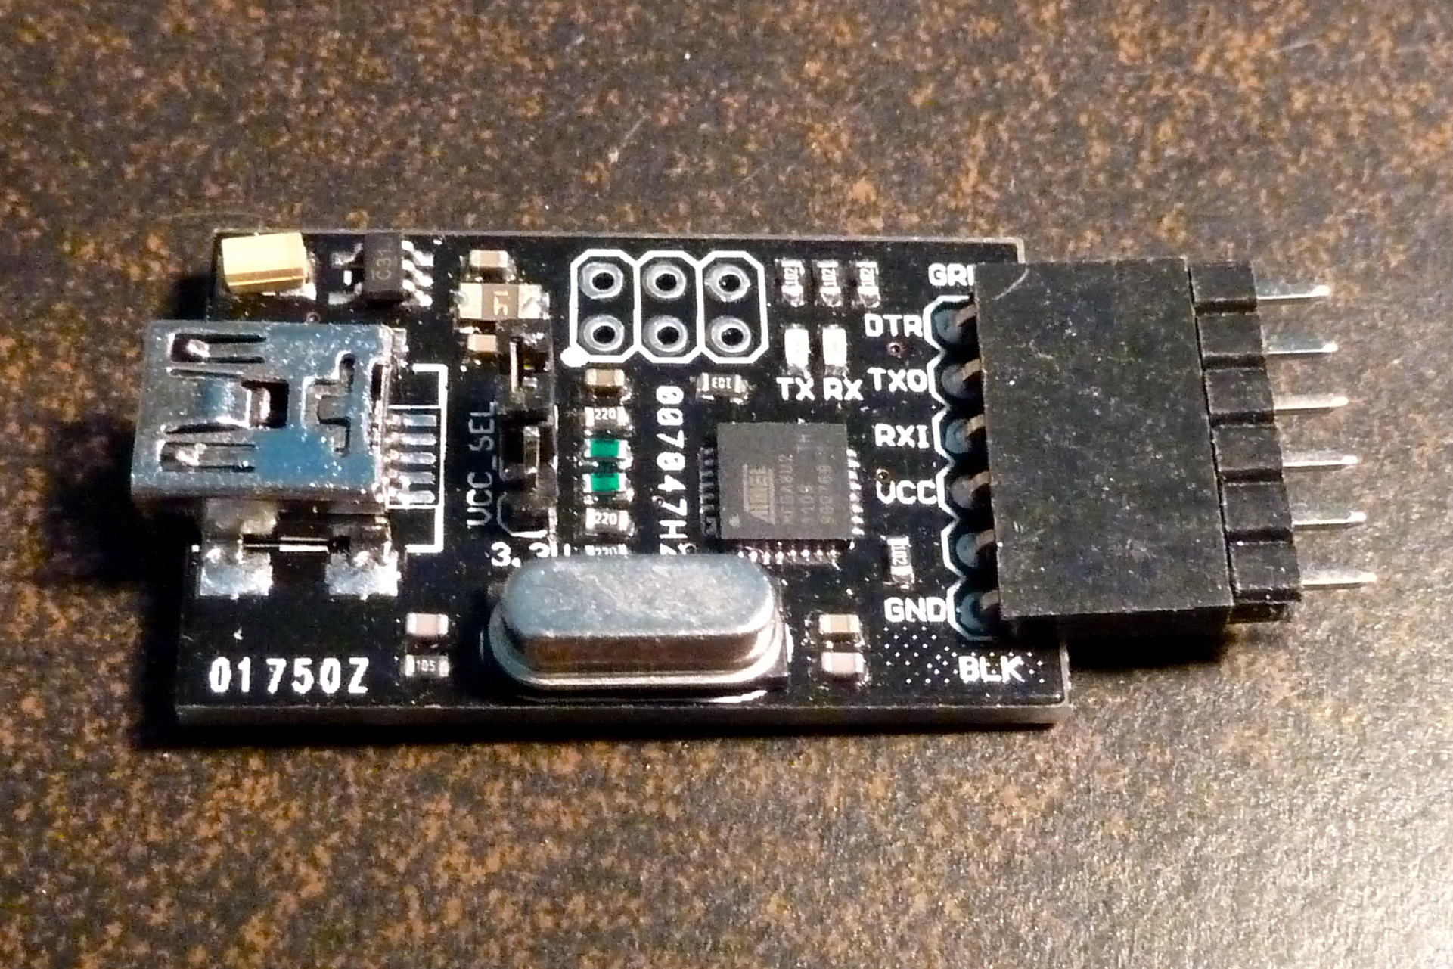
If you are going to reprogram only occasionally, it is possible to do this without installing a header at all. Instead, insert a 1x6 male header (one is provided in a separate package with the USBSerial) into the 1x6 female header on the USBSerial board, as shown to the right. You can now insert this into the FDTI holes on the Io, as shown. You will need to keep a light tension on the USBSerial so that it makes a good connection.

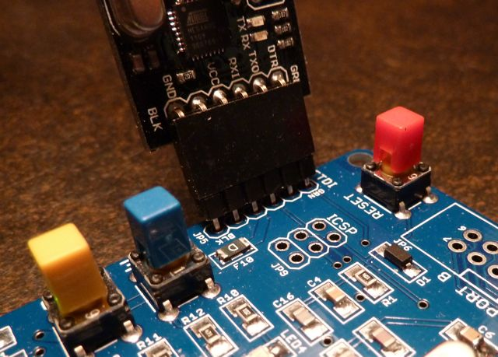
The board can be powered this way, if you move the power-in selector to its USB position. You can now download a new sketch into the Io.

Using ISP

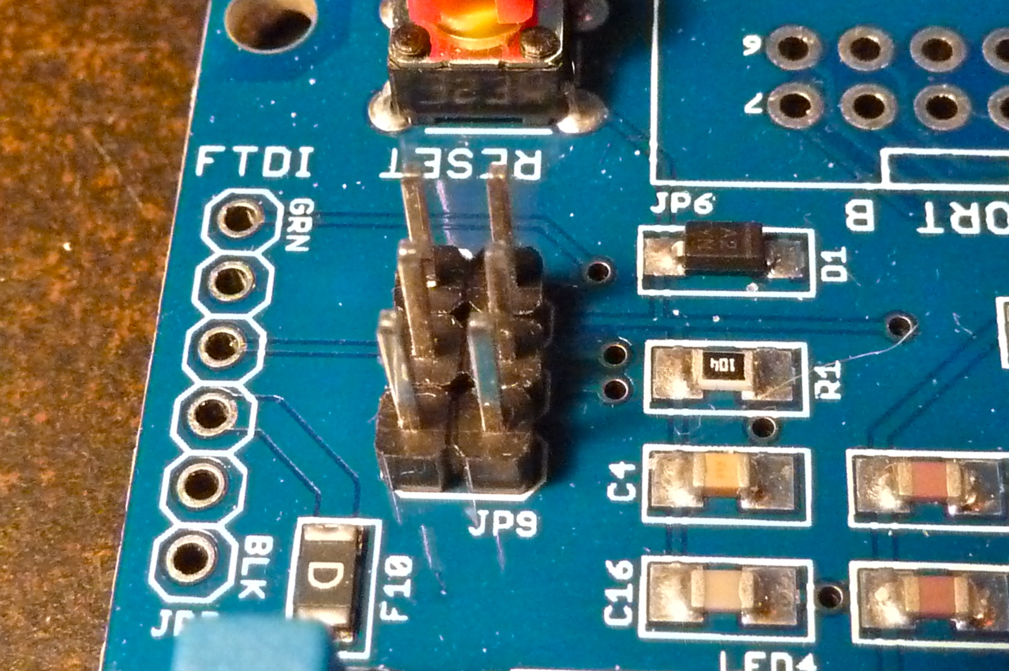
Sometimes you may need to re-program the bootloader or program the board without using the bootloader. This is significantly more involved, and will require a programmer and associated software, such as AVR Studio. This will require the use of the ISP (in-circuit serial programming) connector, JP9. Please note the position of Pin 1 at the bottom right of the connector. See the picture.
Pin 1

Installing A Heat-Sink onto the Power Regulator

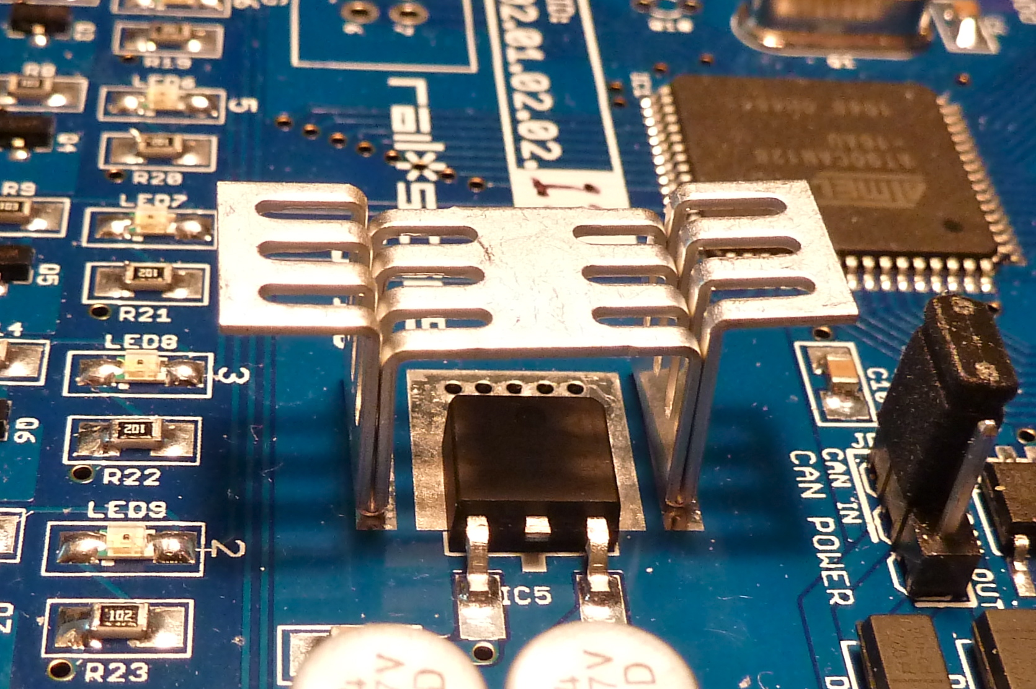
The regulator on the Io board does not usually get hot. However, if the board is driving a large number of LEDs, or other loads, the regulator may become warm or hot. If this occurs, then you can install a heat sink such was supplied with the DevKit. This is soldered into position onto the two bare strips on either side of the regulator, as shown in the picture to the right.

